World Taekwondo IR uniform brand Company _ MJ

Information of World Taekwondo International Poomsae Referee Uniform
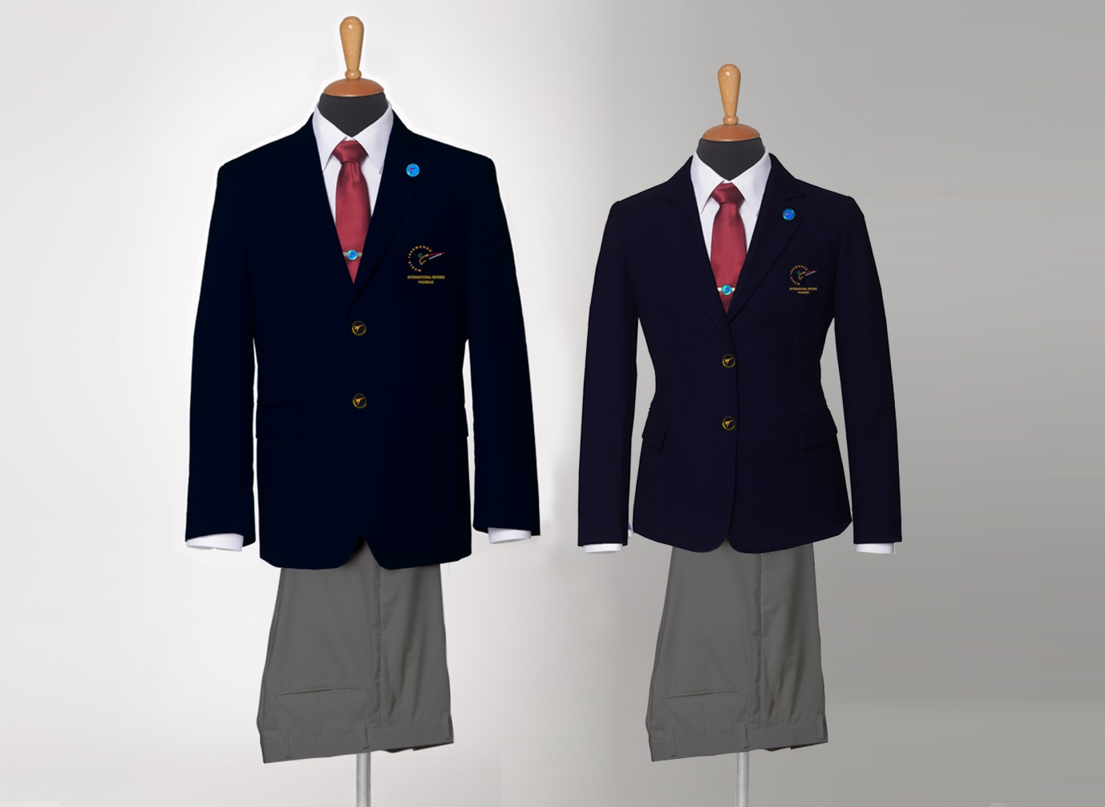
*IMPORTANT NOTICE!
Temporary application schedule for orders, production and delivery due to changes in the logo of the World Taekwondo Federation.
- We will notify you in advance if any changes occur.
- The delivery period will vary depending on the situation in each country.
We are not responsible for delivery.
- Examples of ordering, production, and shipping have been described in an easy-to understand manner.
* Order : For a month
Ordering Period: June 19 - July 25.
* Manufacturing Time : For a month
Manufacture Period: August 1 - August 30.
* Shipping schedule : start September 7~.

2017, May to July Ordering and Manufacture Period, Shipping Schedule
: Ordering and Manufacture Period, Shipping Schedule
- always Ordering and Manufacture Period is : Two Months
- First. Order : For a month
Example) Ordering Period : January 1 - January 25
After the 25th orders will be included next month Order.
- Second. Manufacturing Time for WTF IR Uniform : For a month
Example) Manufacture Period: February 1 - February 25
- Third. Shipping schedule : Manufacturing month last day
Example) start March 7
- The shipping schedule may change depending on the production completion date.
If the shipping schedule is changed, it will be notified.

1. Referee Uniform Detail
- Jacket and Pants
- Long & Short Sleeved dress shirts
- Tie
- WTF Badge and Tie pin
- Suit cover with hanger
- Uniform Sets Price 320USD (Shipping and handling charges will add apply)
* The single products will be available individually with price on our website.

2. Online shop and Contact
- On-line Shop : www.wtf-ir.com
*All products can only be purchased through online shop.
- Contact Email : re@wtf-ir.com
- Company : MJ SPORTS
- Address: 3rd Floor, Pyeongsan Building 434 Seongnae-dong, Gangdong-gu, Seoul, KOREA.
- Zip code : 05406
- T. +82(0)2 477 4055 / +82(0)70 7122 4066
- F. +82(0)2 477 4054
- Nearest subway station : Subway line No.5 - Dunchon Dong station
- Exit number : No. 3
- Our company opening Day of the week and hours are...
Monday to Friday from 10:00 am to 5:00 pm.
Lunch time: From 12:00 to 1:30

3. Order Method
- Go to www.wtf-ir.com (Follow the instructions on the website)
- All the referees can make a purchase. However, referees who have been appointed to 2016 WTF World Taekwondo Grand-Prix Final December in Baku, Azerbaijan will receive their uniform earlier. [Priority]
- Then, the delivery will be made in the order

4. Payment Method
- After confirmation of your order, you will be directed to the PayPal login page.
- Bank Transfer (Follow the instructions on the website)
- Shipping and handling charge will be included.
- The rules of our company. When you complete the payment, we can confirmation and it can produce your products.

5. Shipping Info.
- Please double check your order and shipping address.
- The items (Uniform) will be delivered an after ordering and Manufacture period. (after 55days ~ 60days)
- The rules of our company. When you complete the payment, we can confirmation and it can ship your
products.
- Please double check your order and shipping address.

6. Return and Exchange Policy
- Online purchases made through MJ CO are valid for exchange, credit, or refund within 30 days from the delivery start date.
- We recommend using a carrier service that provides tracking.
- Please send us your products through EMS(international post office mail) or Fedex, UPS, ETC. Please note: only standard delivery services will be refunded.

Your return and invoice provide a postmark date that specifies the last day you have to return your merchandise by mail or to one of our stores.
You must contact our Customer Service department before mailing your returns.
If you would like to return your order by mail, please contact our Customer Service department.
by email : re@wtf-ir.com.
We will issue you a Return Authorization and give you further instructions.
Your online purchase cannot be returned in-store.
We are not able to accept blind returns.

- Change size or item due to mistake by the customer
: Buyer is responsible for the cost of replacing and returning goods ordered in buyer fault. You will be responsible for all return shipping fees.
We will not reimburse for original shipping.

- Not refund or exchange
: Items must be returned unwashed, unworn, undamaged products, undamaged package and with tags attached.
: Necktie, Badge and necktie pin must be in its original packaging.
: All returned items must be accompanied by the original ordered sheet and customs documents (if applicable).

- 3. Refund or exchange in case
: Defective Product production, Defective Product subsidiary materials, Material defect. (Damaged, Defective, or Wrong Item(s))
We will refund the return shipping costs if a copy of the shipping receipt is attached to the Return Form.
Note that returns will be credited in the same currency and same exchange rate you as your original order.

